**Testing guidelines for the Sheet – Time Series Gender Ratio**

This sheet focusses on the comparison of gender ratio in accordance to a fixed timeline.

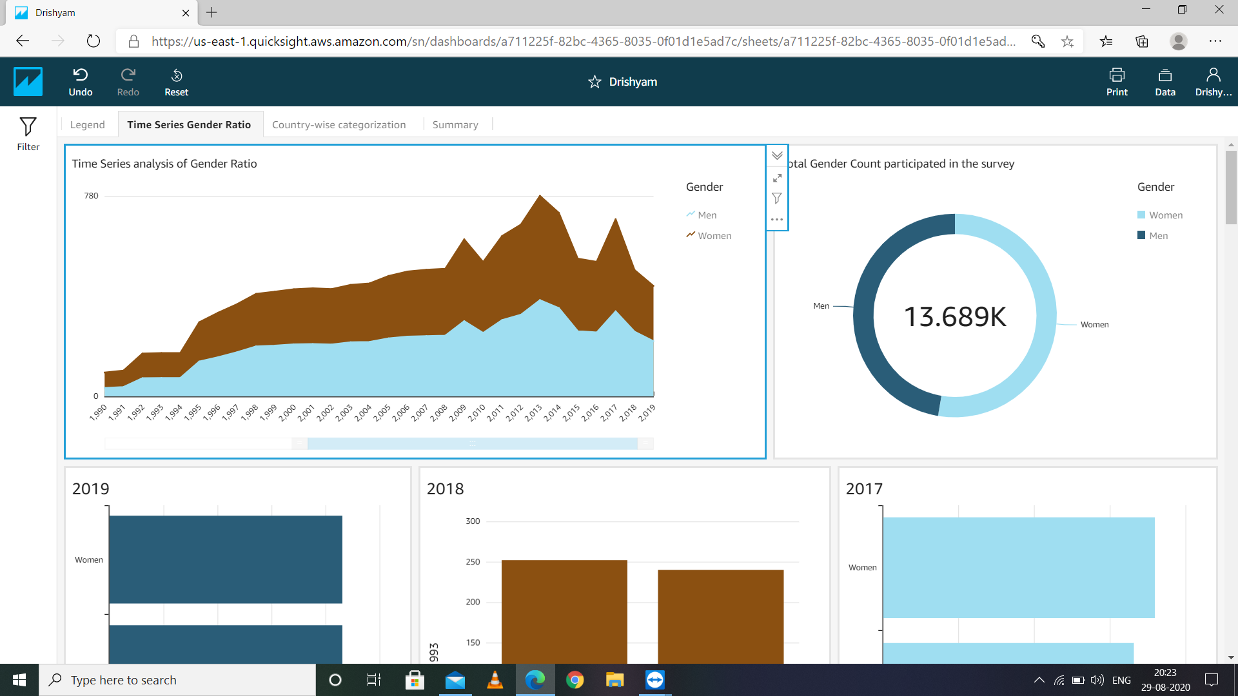

The span of the timeline included in the OECD dataset is from the year 1976 to 2019.

Mainly there are three type of Visualization in this sheet:-

1. **Time Series analysis of Gender Ratio –** This visualization shows the time series graph of both the genders over the years spanning from 1976 to 2019.From this chart it can be conclude that there is ample increment in the number of people who decided to start their own businesses.
2. **Total Gender Count participated in the survey -** Here it can be seen that there is a possibility that the same people are being surveyed for each consecutive year, hence leading up to the total count of 13.6K+. Also, the percentage ratio of Men:Women is 47:53 according to this survey, which is nearly 1:1.
3. **Year-wise detail (2019-1976) -** In the rest of the sheet, a detailed comparison of the gender count of entrepreneurs in each year has been shown. There are 28 such visualizations in this sheet.

Step 1 - Click on any visualization to get further access to it.

1. **Time Series analysis of Gender Ratio**
2. On the visualization, click on the desired year, you will find out the gender ratio of working entrepreneurs of that particular year.

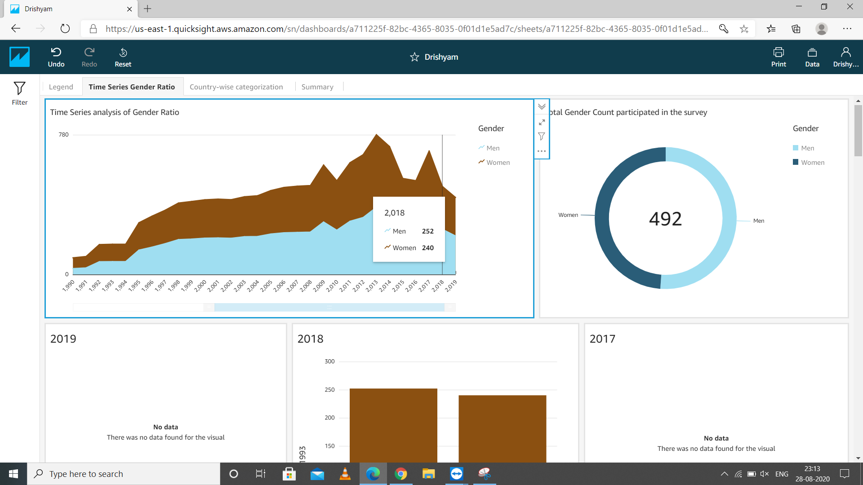

(NOTE:- When a particular year has been selected, the graphs of other years would read “No data – There was no data found for the visual”, which makes sense because it will show the year data of that particular year only)

1. **Total Gender Count participated in the survey**
2. Hover over the gender of which you want to know the count for.

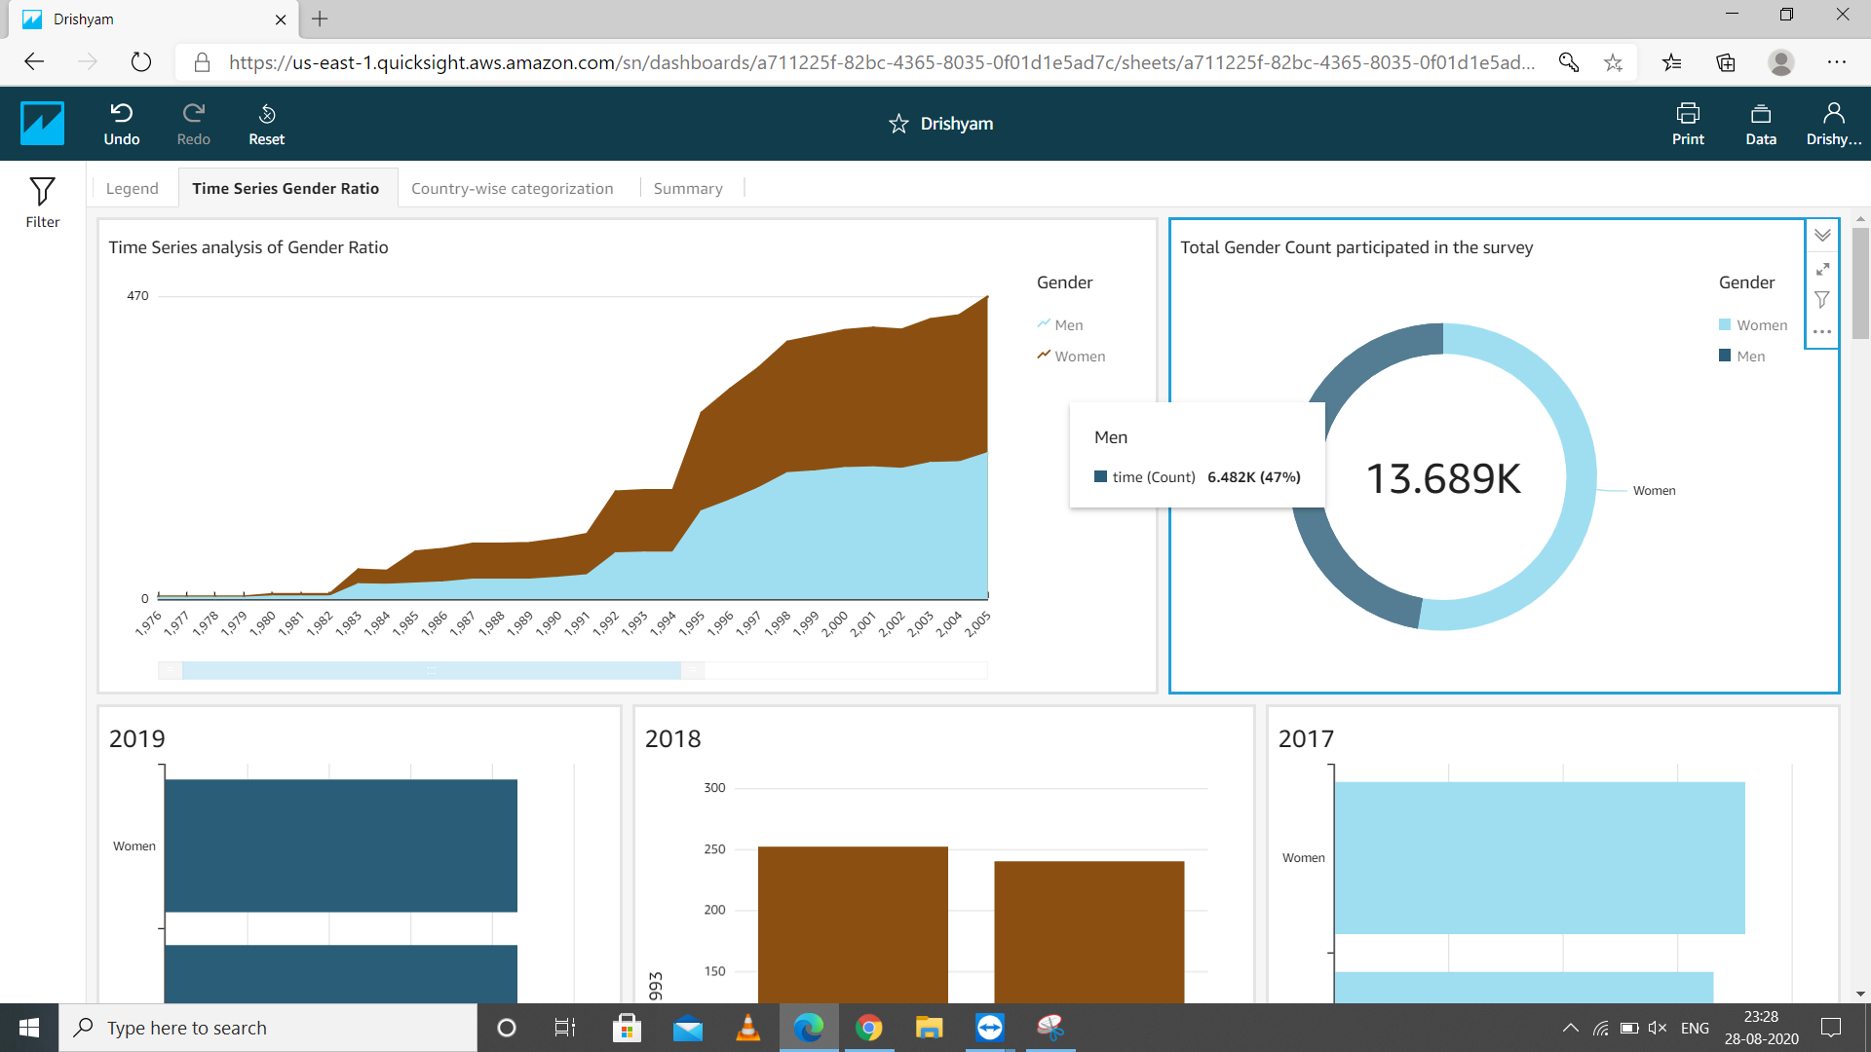

1. You may also click on any of the genders to fine-tune the entire sheet in accordance to that gender only.

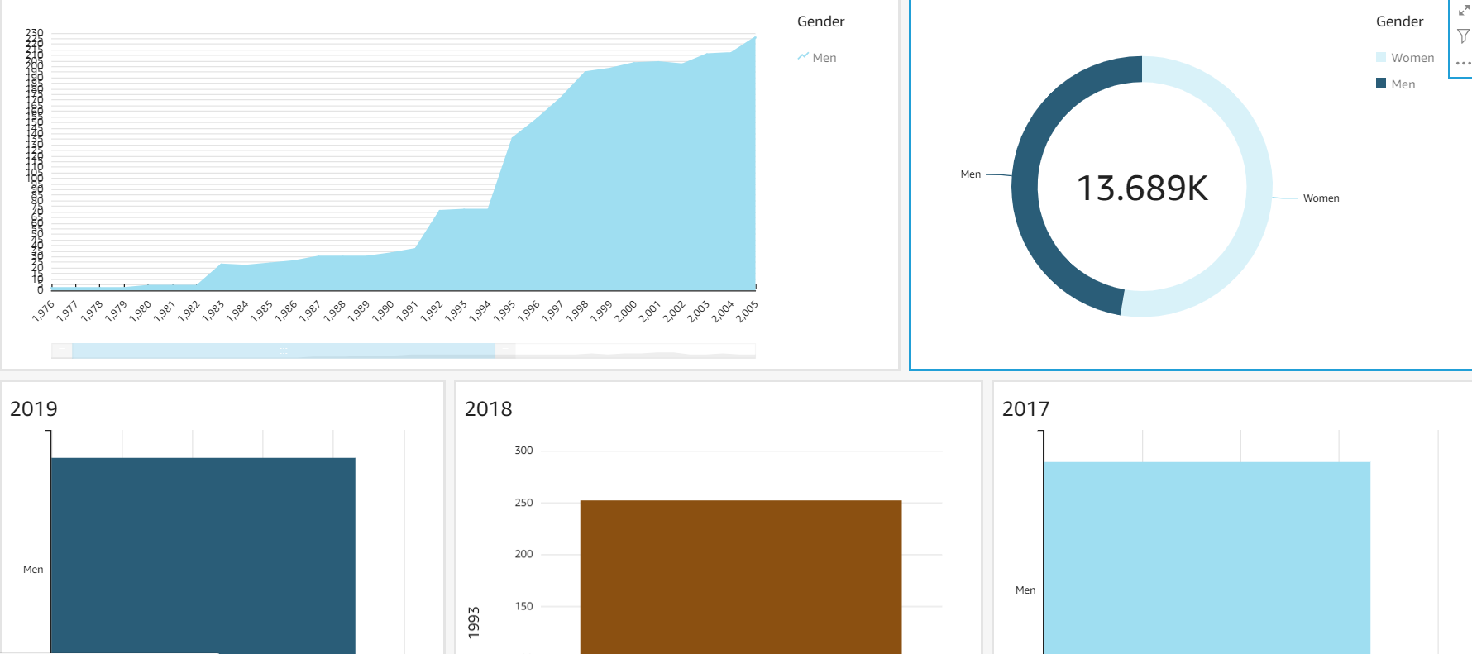

1. **Year-wise detail (2019-1976)**
2. You can go through the rest of the sheet to search for any particular year’s data.

